**AP Calculus AB: Summer Packet**

**Moorestown High School Math Department**

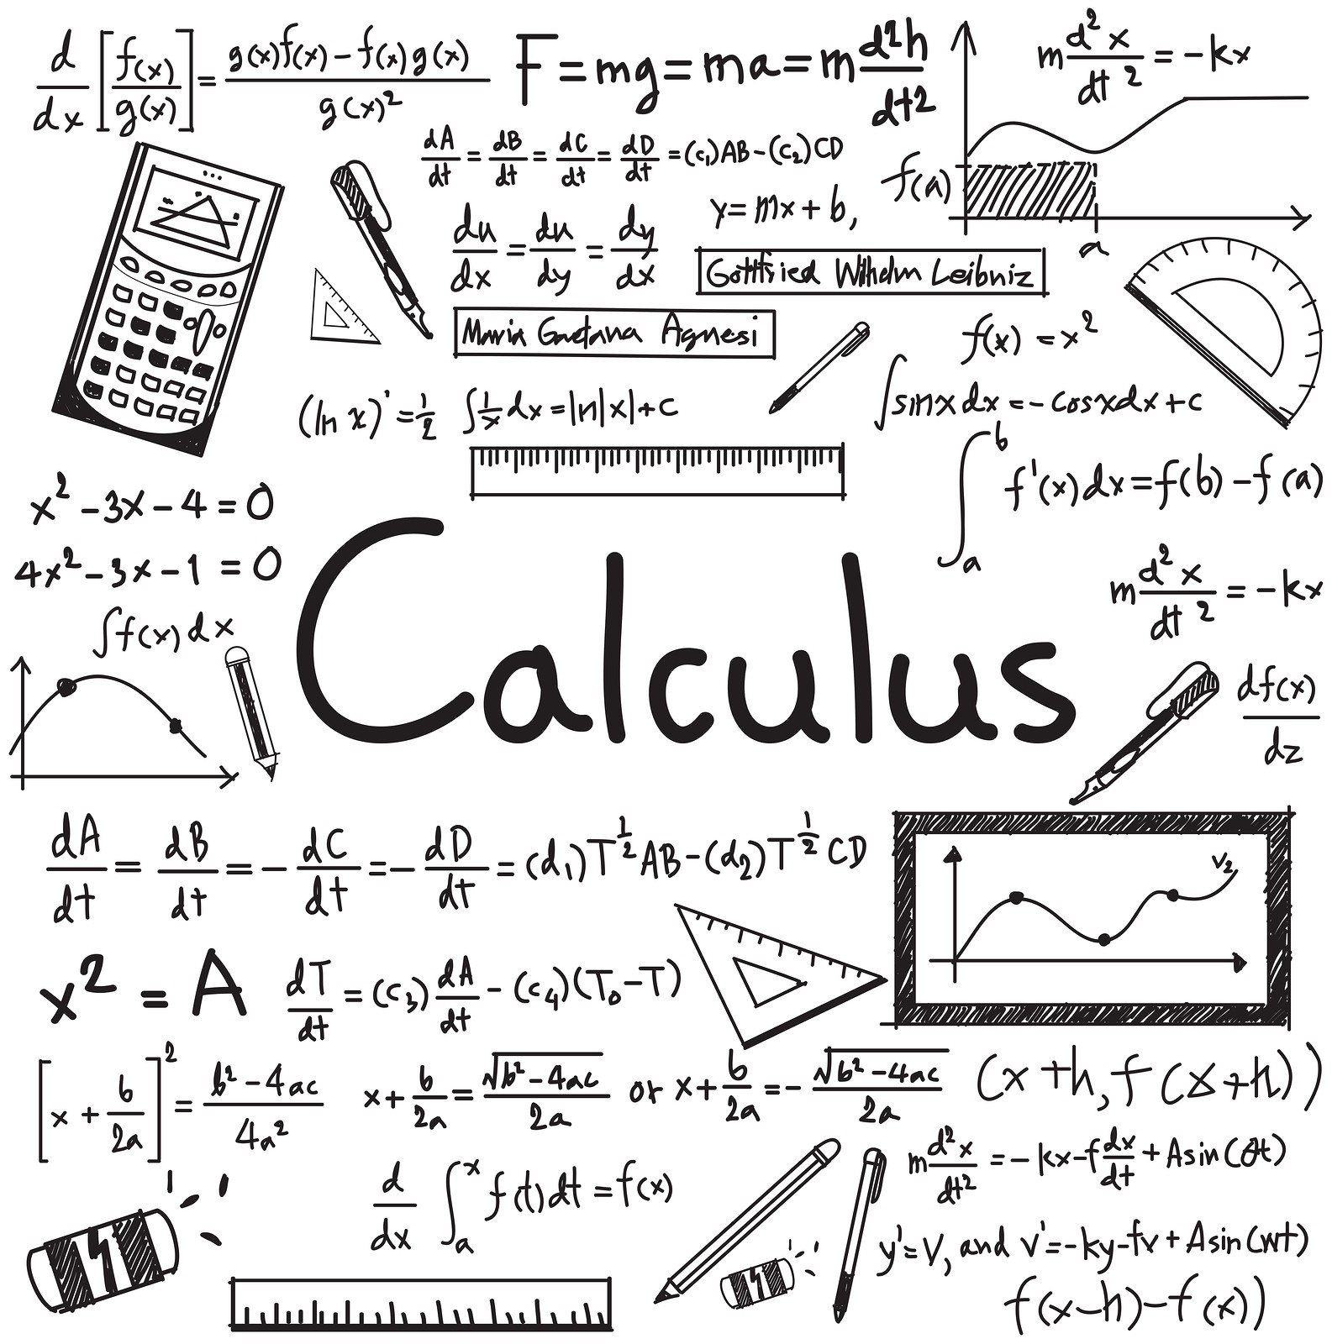

Name: ______________________________

**READ THIS FIRST**

AP Calculus AB is a great class and you will leave this class well prepared for a college-level Calculus I class. However, there will be times that the class will be very difficult for multiple reasons. First, the content itself is more difficult than what you’ve seen before, so be prepared to study. Second, you will be asked to apply the content in ways you haven’t been asked to do before, so be ready to test your metacognitive skills and start thinking about your thinking. And third, most of you taking this class are seniors, and there will be times when you won’t want to do much of anything. I need to you to focus and work really hard until we finish the curriculum around March or April. After that, we’ll still be working, but it will be at a slower pace.

In order to be successful in Calc AB, it is extremely important that you have a strong grasp of simple and intermediate Algebra skills. Some of the most common mistakes that I see students make throughout the year involve the rules of simplifying complex fractions, factoring, using negative exponents, finding domain, etc. It is hard to wrap your head about the conceptual topics if you’re getting the wrong answer because you made a simple mistake. This packet will be used to help you practice these skills so that we can start class in September ready to go.

This packet will be collected on the first day of school and it will be graded. You are expected to do every problem and show all of your work. You will not get credit for problems without work shown. You will not get credit for work that is clearly copied from someone else or work that is made up or nonsensical. Take this seriously. In addition, this packet will allow me gauge your abilities at the start of the school year.

Do not do this packet in June. Take a mental break from school and come back to this in August. I want these topics to be fresh in your mind for September. There are 13 topics. You can spend two weeks and do one topic per day, or spend one week and do two topics per day. Either way, this will not be a huge undertaking as long as you commit some time. It is not recommended to do all 13 topics on Monday of Labor Day weekend.

Below is a list of the topics that are covered in the packet. If you are unable to do these problems from memory, you are expected to figure them out on your own. For help, it is suggested that you review previous math notebooks, ask a friend for help, or do a Google search for the topic. There are websites like [www.purplemath.com](http://www.purplemath.com) and [www.khanacademy.org](http://www.khanacademy.org) that are good resources for reviewing and relearning material. The topics covered in this packet are:

1. Negative and fractional exponents
2. Domain
3. Solving absolute value inequalities
4. Factoring
5. Transformations of functions
6. Even and odd functions
7. Solving quadratic equations
8. Asymptotes
9. Complex fractions
10. Composition of functions
11. Solving rational equations
12. Right angle Trig
13. Trig equations

**Topic 1: Negative and Fractional Exponents**

Simplify using only positive exponents.

|  |  |  |
| --- | --- | --- |
|  |  |  |
|  |  |  |
|  |  |  |

**Topic 2: Domain**

Find the domain of the following functions.

|  |  |  |
| --- | --- | --- |
|  |  |  |
|  |  |  |
|  |  |  |
|  |  |  |

**Topic 3: Solving Absolute Value Inequalities.**

Write the following absolute value expressions as piecewise expressions.

|  |  |  |
| --- | --- | --- |
|  |  |  |

Solve the following absolute value inequalities.

|  |  |  |
| --- | --- | --- |
|  |  |  |
|  |  |  |

**Topic 4: Factoring**

Factor completely.

|  |  |  |
| --- | --- | --- |
|  |  |  |
|  |  |  |
|  |  |  |

**Topic 5: Transformations of Functions**

If , describe in words what the following would do to the graph of .

|  |  |  |
| --- | --- | --- |
|  |  |  |
|  |  |  |

Here is a graph of . Sketch the following graphs.





|  |  |  |
| --- | --- | --- |
|  |  |  |
|  |  |  |

**Topic 6: Even and Odd Functions**

Show work to determine if the relation is even, odd, or neither.

|  |  |  |
| --- | --- | --- |
|  |  |  |
|  |  |  |
|  |  |  |

**Topic 7: Solving Quadratic Equations**

Solve each equation.

|  |  |  |
| --- | --- | --- |
|  |  |  |
|  |  |  |
|  |  |  |

**Topic 8: Asymptotes**

For each function, find the equations of all vertical and horizontal asymptotes (if they exist).

|  |  |  |
| --- | --- | --- |
|  |  |  |
|  |  |  |
|  |  |  |

**Topic 9: Complex Fractions**

Simply the following.

|  |  |  |
| --- | --- | --- |
|  |  |  |
|  |  |  |
|  |  |  |

**Topic 10: Composition of Functions**

If , , and , find the following.

|  |  |  |
| --- | --- | --- |
|  |  |  |
|  |  |  |
|  |  |  |

**Topic 11: Solving Rational Equations**

Solve each equation.

|  |  |  |
| --- | --- | --- |
|  |  |  |
|  |  |  |
|  |  |  |

**Topic 12: Right Angle Trig**

For #1-2, if point  is on the terminal side of , find all 6 trig functions of . Draw a picture.

|  |  |
| --- | --- |
|  |  |
| 1. If ,  is in quadrant II, find  and . | 1. If ,  is in quadrant III, find  and . |

Find the exact value of the following without a calculator.

|  |  |  |
| --- | --- | --- |
|  |  |  |

Solve the following triangles (final answers should be rounded or truncated to 3 decimal places).

|  |  |
| --- | --- |
|  |  |

**Topic 13: Solving Trigonometric Equations**

Solve each equation on the interval .

|  |  |  |
| --- | --- | --- |
|  |  |  |
|  |  |  |
|  |  |  |